How to create a Transfer booking in DOTW?
To create a New TRANSFER Booking, the NEW BOOKING link in the Operations section would need to be clicked. This will pull down a drop-down list, showing the available services to book. The user would need to click on TRANSFER BOOKING.

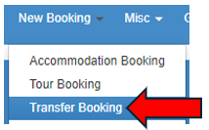

This will load the next page, where the customer’s profile would need to be input. To do this, the user would need to encode the client’s name in the COMPANY NAME field and choose the correct customer profile from the list of the customers that would pop up. Once the correct profile is found, one can now click on the FILTER CUSTOMERS button.

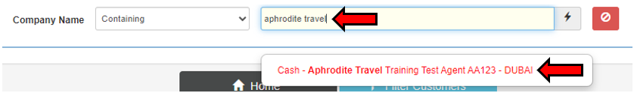

Filtering the customers profile would allow one to see all the DOTWConnect user profiles the client has with us. Clients would usually have multiple user profiles under their accounts.

If the client has a specific preference under which account the booking is to be placed, the specific user account mentioned should be the one chosen. On the other hand, if the client did not specify which user account to use, the profile tagged as MAIN USER can be chosen.

Once the client’s profile has been chosen, the next page will allow a WebBeds user to input the search filters for the transfer booking needed to be booked. The first row will allow for the PICKUP FROM and DROP OFF TO Information to be input.

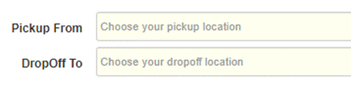
The information indicated in the Pickup from and DropOff To will allow DOTWConnect to automate which transfer availability to offer.

If an arrival transfer needs to be booked, then:
Pickup From: should be from the name of the Airport the guest will be arriving in; while
DropOff To: should be the name of the hotel the guest will be staying at.

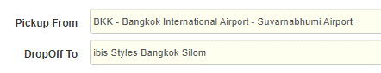

Subsequently, if it is a departure transfer that needs to be booked, then:
Pickup From: should be the name of the hotel the guest is staying at; while
DropOff To: should be the name of the airport that the guest will be departing from.

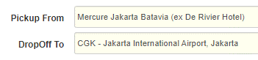

Once the Pickup From and DropOff To Fields are filled out, the filters in the lower part of the page will automatically adjust, depending on what kind of transfer is being booked.

If it is an ARRIVAL TRANSFER that is being booked, a WebBeds user will be requested to input the FLIGHT ARRIVAL DATE and TIME, together with the TOTAL # OF TRAVELLERS.

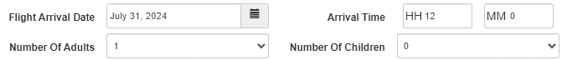

On the other hand, if it is a DEPARTURE TRANSFER that is being booked, a WebBeds user will be requested to input the FLIGHT DEPARTURE DATE and TIME, together with the TOTAL # OF TRAVELLERS. The Flight Arrival or Departure Time that would need to be input should be based on the flight itinerary of the guests.

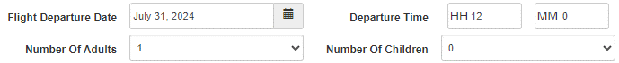

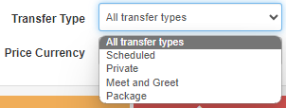
If the client specified a specific type of transfer that the guest would like to book, it is possible to filter the results via the Transfer Type filter. A WebBeds user can filter for Scheduled (Group), Private, Meet and Greet or Package transfers.

If there is no preference mentioned, ALL TRANSFER TYPES can be chosen.

By default, the PRICE CURRENCY would be the main currency that the client has chosen to pay for their WebBeds bookings. However, if the client would like to pay for the booking using a different currency, a WebBeds user can click on the drop-down box for Price Currency to see what the available currencies are to change to.

It is only possible to change the currency for Selling Price during the time of the booking. Once it has been booked, it is not possible to be changed.

Once all appropriate booking search filters have been adjusted and input, the Search button may be clicked. The DOTWConnect system will display, in the lower part of the page, the results based on the information filtered. The search results can also be sorted chronologically by price.

Transfer search results would first present a summary of the service and its availability, which includes the:

- Transfer Information - gives a user access to the important information about the transfer, such as Maximum Supplier Wait Time, Baggage Allowance, Transfer meeting point and cancellation policy, among others.
- Transfer Service Name
- Transfer Type
- Lowest selling price available for the service
- Get Transfers button, which will expand and present all types of automobiles available for the service.

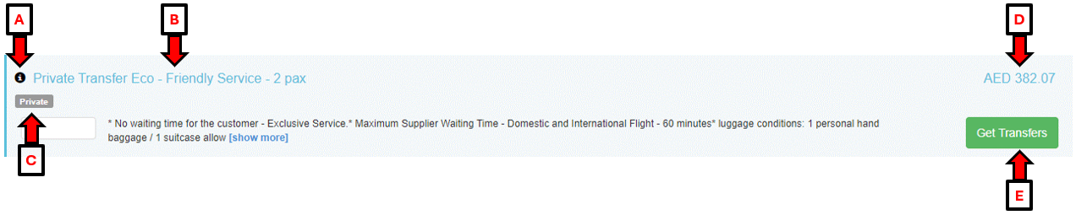

Clicking on the GET TRANSFERS button will allow DOTWConnect to show the available automobiles for the transfer service, their cancellation deadlines, and the total selling price. A team member will have access to this information, when looking at the transfer availability:

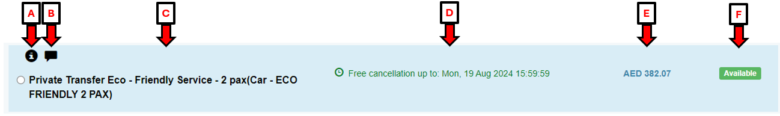

- Transfer Information: gives a user access to the information about the service, including the maximum capacity of the automobile and allowed luggage/baggage capacity.

- Rate/Tariff Notes: gives a user access to the cancellation/amendment deadline and penalties that apply for the booking. In addition, additional important policies from the supplier, such as baggage allowance, extra luggage accepted and required documents for the transfer are noted here, as well.

- Transfer Name and Type: gives a user information about the transfer’s name and type.

- Cancellation Deadline: gives a user information regarding the cancellation deadline for a transfer booking, which is in the client’s time zone.

- Total Selling Price: gives a user information the total selling price for the transfer booking, inclusive of all taxes and fees.

- Service Availability: gives a user information if the transfer is AVAILABLE or ON REQUEST.

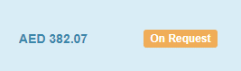
If a transfer is showing as ON REQUEST, it is important to inform the client needs to be these needs to be coordinated first with the transfer supplier if this can be confirmed, prior to booking. Most suppliers may confirm the booking but require specific information about the transfer prior to confirming.

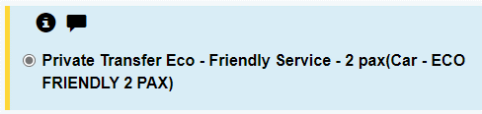
Once a team member has found the transfer that would like to be booked, the tick circle beside the transfer’s name would need to be clicked. Afterwards, the PROCEED TO BOOKING button, at the end of the availability, would need to be clicked.

A pop-up box will show, wherein the user will need to input the names of the guests, their pickup and drop off details, and any special requests for the transfer, if any. Depending on how many guests are being booked and the transfer’s maximum occupancy, a team member may be allowed to book multiple vehicles for the guests.

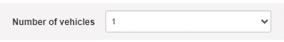

The number of guest names that will need to be input depends on the kind of supplier. Some suppliers require only the lead guest’s name, while others require all guests’ names. A team member needs to ensure to use English characters only, no special characters used and that there are no spaces at the beginning or end of the names.

Once all the guest names, pick up and drop off information and preferences are correctly input, and the terms and conditions are read, the green BOOK TRANSFERS button can now be clicked. It will lead DOTWConnect to make the booking itself. Once the booking is created, it will bring the user to the full booking summary.

How to create a Tour booking in DOTW?
To create a New TOUR Booking, a user would need to click on the NEW BOOKING link in the Operations section. This will pull down a drop-down list, showing the available services to book. The team member would need to click on TOUR BOOKING.

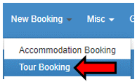

This will load the next page, where the customer’s profile would need to be input. To do this, the user would need to encode the client’s name in the COMPANY NAME field and choose the correct customer profile from the list of the customers that would pop up. Once the correct profile is found, the user can now click on the FILTER CUSTOMERS button.

Filtering the customers profile would allow a user to see all the DOTWConnect user profiles the client has with us. Clients would usually have multiple user profiles under their accounts.

If the client has a specific preference under which account the booking is to be placed, the specific user account mentioned should be the one chosen. On the other hand, if the client did not specify which user account to use, the profile tagged as MAIN USER can be chosen.

Once the client’s profile has been chosen, the next page will allow a WebBeds user to input the search filters for the tour booking needed to be booked. The first rows will allow for the DESTINATION CITY or the TOUR NAME Information to be input. Any of the two search filters can be used to search for tours, depending on what information the client gave in their request.

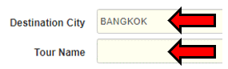

Once the DESTINATION CITY OR TOUR NAME fields are filled out, the next information requested to be filled out would be the DATE OF THE TOUR and the TOTAL NUMBER OF TRAVELLERS.

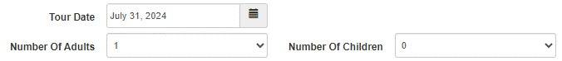

If the client specified a specific tour type that the guest would like to book, it is possible to filter the results via the Tour Type filter, whether a SCHEDULED or PRIVATE Tour is requested. If there is no preference mentioned, ALL TOUR TYPES can be chosen.

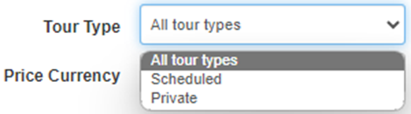
By default, the PRICE CURRENCY would be the main currency that the client has chosen to pay for their WebBeds bookings. However, if the client would like to pay for the booking using a different currency, a WebBeds user can click on the drop-down box for Price Currency to see what the available currencies are to change to.

It is only possible to change the currency for Selling Price during the time of the booking. Once it has been booked, it is not possible to be changed.

Once all appropriate booking search filters have been adjusted and input, the Search button may be clicked. The DOTWConnect system will display, in the lower part of the page, the results based on the information filtered. The search results can also be sorted chronologically by price.

Tour search results would first present a summary of the service and its availability, which includes the:

- Tour Information - gives a user access to the important information about the tour, such as the tour description and operating hours, transfer meeting point (if included) and emergency numbers, among others.
- Tour Service Name
- Tour Type
- Lowest selling price available for the service
- Get Tours button, which will expand all available options for this service

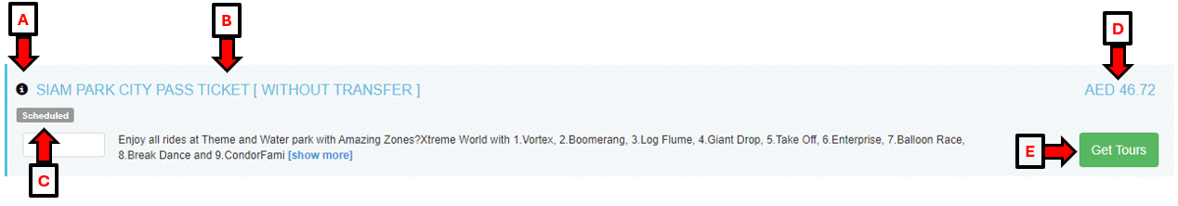

Clicking on the GET TOURS button will allow DOTWConnect to show the available options for the tour service, their cancellation deadlines, and the total selling price. A team member will have access to this information, when looking at the tour availability:

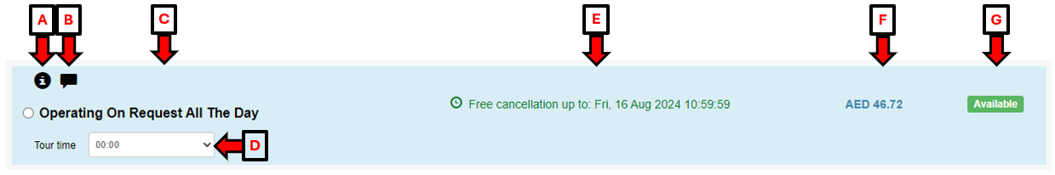

- Tour Information: gives a user access to the information about the service, including the meeting point for the tour.

- Rate/Tariff Notes: gives a user access to the cancellation/amendment deadline and penalties that apply for the booking. In addition, the supplier’s emergency number can be seen here.

- Transfer Name and Type: gives a user information about the tour’s name and type

- Tour Time: gives a user the ability to choose a specific tour time to book, for tours which have specific times for their service.

- Cancellation Deadline: gives a user information regarding the cancellation deadline for a tour booking, which is in the client’s time zone

- Total Selling Price: gives a user information the total selling price for the tour booking, inclusive of all taxes and fees

- Room Availability: gives a user information if the transfer is AVAILABLE or ON REQUEST.

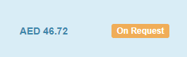
If a transfer is showing as ON REQUEST, it is important to inform the client needs to be these needs to be coordinated first with the transfer supplier if this can be confirmed, prior to booking. Most suppliers may confirm the booking but require specific information about the transfer prior to confirming.

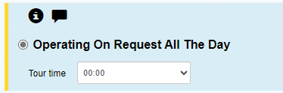
Once a team member has found the tour that would like to be booked, the tick circle beside the tour’s name would need to be clicked and tour time to be chosen, if applicable. Afterwards, the PROCEED TO BOOKING button, at the end of the availability, would need to be clicked.

A pop-up box will show, wherein the user will need to input the names of the guests, their pick up and drop off details, and any special requests for the transfer, if any.

The number of guest names that will need to be input depends on the kind of supplier. Some suppliers require only the lead guest’s name, while others require all guests’ names. A team member needs to ensure to use English characters only, no special characters used and that there are no spaces at the beginning or end of the names.

Prior to confirming the Tour booking, a user may be asked for a Pick-Up location. This will need to fill out with a specific hotel name if the tour booked includes round trip transfer from and to the hotel. If the tour booked does not include any transfer, then “N/A” can be placed in the pick-up location.

Once all the guest names, and preferences are correctly input, and the terms and conditions are read, the green BOOK TOURS button can now be clicked. It will lead DOTWConnect to make the booking itself. Once the booking is created, it will bring the user to the full booking summary.

